# Overview

In this guided practice you will create a central policy store for the administrative templates used by Group Policy.

# Objectives

* Be able to manage **Group Policy** objects.

# Prerequisites

Guided practice – **Modifying Group Policy Processing** is complete.

# Scenario

Your organization is interested in centralizing the management of user and computer settings. It would like to do this using **Active Directory and Group Policy**. They would like you to test out the operation of **Group Policy** in the guided practice so that you can later provide a plan for using **Group Policy** to manage user and computer settings.

# Tasks

Many of the settings in **Group Policy** are registry based. The information about the policy names, registry keys, and possible values are stored in **adm/admx** files. When a group policy is created that uses administrative templates, the associated **adm/admx** file must be replicated with it. These templates are updated with each new version of the operating system. This creates the possibility of having different versions of templates being replicated between domain controllers increasing the possibilities for errors and increasing replication bandwidth. To prevent this, you can create a central policy store from which all domain controllers will copy their templates, reducing bandwidth and preventing version conflicts.

## Creating a Central Policy Store

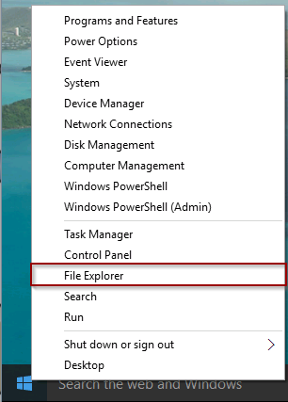The policy definitions for the central store should come from the newest operating system, client or server that you have. In this case, the newest operating system is Windows 10. To copy the policy definitions from one of our clients.

1. Login to the **CIS256-Client1** virtual machine with **ABSadmin**.
2. Right-click the **Windows** icon in the lower left corner of the screen and select **File Explorer** as shown in the figure to the right.
3. Browse to **C:\Windows**.
4. Using the context menu, copy the **PolicyDefinitions** folder**.**
5. Browse to the location of the group policies in the **SysVol** share on the domain controller by typing **\\absdc1\sysvol\abscorp.com\Policies.**
6. Paste the **PolicyDefinitions** to this location. You should see something like the screen below. You may have less policies in this folder depending on your location in the guided practice.

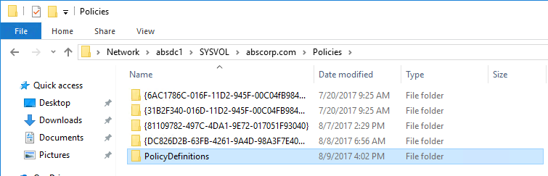

Verify the central policy store as created, perform the following:

1. Logon to the **CIS256-DC1** virtual machine
2. Open the **Group Policy Management** console**.**
3. Select any **Group Policy Object** and select **edit** from the context menu.
4. Expand the **Policies** node and hover your mouse over the **Administrative Templates** node.
5. 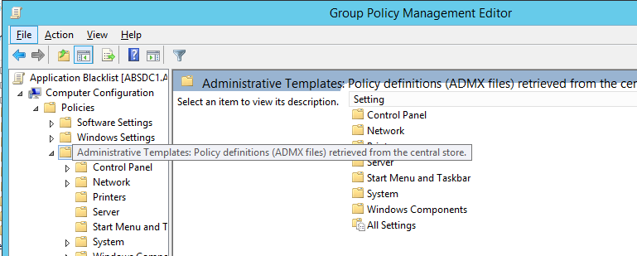You should see a screen tip like the one shown below indicating that the **admx** templates have been loaded from a central location.

## Submission REquirements

1. **Download** the **grading** **script** from the assignment page to the **C:\Scripts** folder.
2. Check your lab by running the following command:

C:\Scripts\GP-15-PolicyStore.ps1

1. You should not see any red in the output. Red in the PowerShell way of telling you that an error condition exists. Most of the time, the output will tell you what is wrong. If it is not obvious, contact your teacher and ask for assistance. You will be learning PowerShell during this term. **Correct** any **errors** you may have and run the script until all the output has no red. You should see the output like the images below

1. Capture a snippet that shows the PowerShell Command and all its output. If you must use more than one snippet to capture the output, you must have at least **one line of overlap** in the snippets. The text in the snippets **must be legible** when pasted into the Word document. Paste the snippet(s) into a **new** **Word** **document.** Save the file as **PolicyStore_*Firstname*_*LastName*** (where ***Firstname*** is your first name and ***Lastname*** is your last name).
2. **Upload** the **document** in the submission area of this assignment.